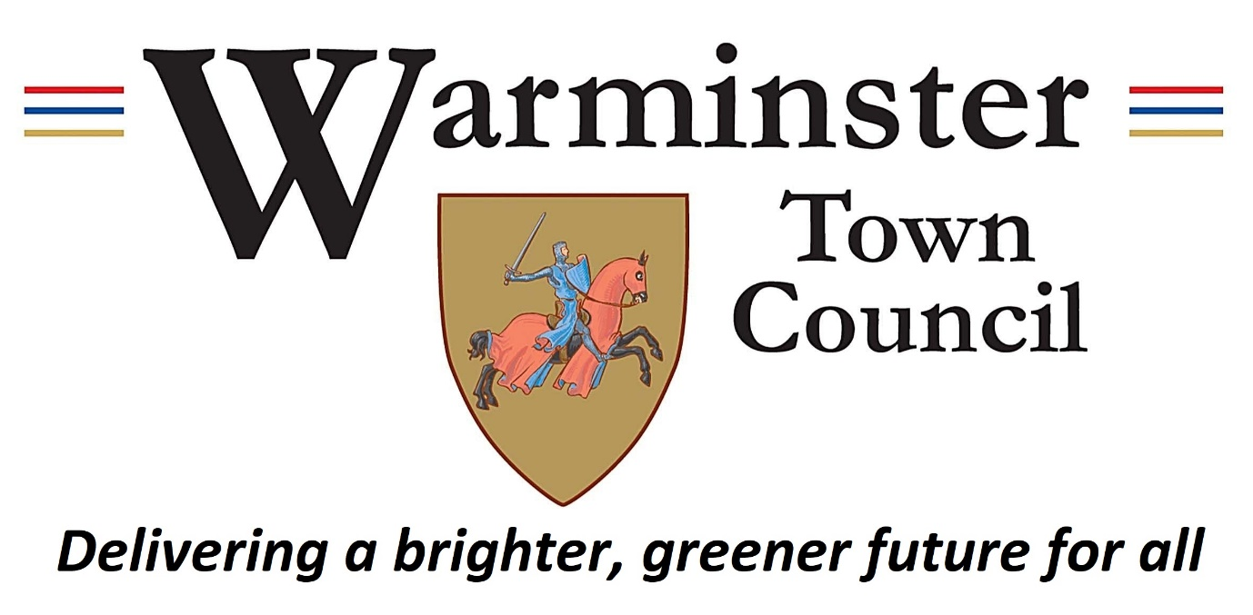The Warminster Civic, Junior Civic, Green Civic, and Environmental Awards are a recognition of the outstanding contribution towards the betterment of the people and town of Warminster.

The Awards are as follows:
- The Civic Award (over 18 years of age) made to an individual who has made a significant difference for the community of Warminster,
- The Junior Civic Award (under the age of 18) given to an individual for achievement within the community,
- The Green Civic Award for environmental issues – for setting an example or changing behaviour of others - which can be awarded to an individual, or group,
- The Environmental Award for businesses to recognise their contribution towards tackling climate change and working towards net zero.

The judging of nominees will be carried out by the full Warminster Town Council members and will be based on:
- highlighting the example of community spirit,
- focusing on those who have ‘gone the extra mile’,
- motivating others to act positively, which will be considered as important as individual efforts.

The four Civic Awards are held in equal standing and celebrated with a certificate from the Mayor of Warminster. The award ceremony will be a tea of thanks with the Mayor and other members of the Town Council on Monday 9th December 2024 at the Civic Centre. Photos of the award presentation will be issued with a press release containing a write up about each recipient.

Nominations must be treated as confidential, and the nominee should not be aware that they have been nominated.

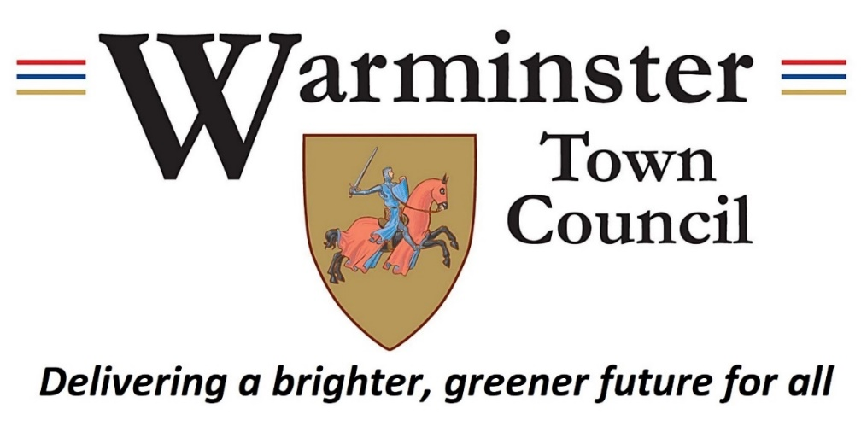

The Warminster Civic Award Nomination Form 2024

I, (name of proposer) Click or tap here to enter text.
of, (address) Click or tap here to enter text.
Email Click or tap here to enter text.Email: Click or tap here to enter text. Phone Click or tap here to enter text. Phone: Click or tap here to enter text.
Nominate
Name: Click or tap here to enter text.
Address: Click or tap here to enter text.
Email: Click or tap here to enter text.
Phone: Click or tap here to enter text.
for their services to the community of Warminster, to receive the (click the relevant box):
☐ Civic Award ☐ Junior Civic Award
☐ Green Civic Award ☐ Environmental Award
I certify that the details given are correct, that I have not been influenced or canvassed in any way and that the person, business, or organisation nominated has no knowledge of the nomination. I understand that all matters relating to the nomination are confidential.
Signed: Click or tap here to enter text. Date: Click or tap here to enter text.

Please complete the next page

Your nomination for the Civic Award should be for a person, business, or organisation who has made a significant difference to Warminster, having demonstrated community spirit, motivated others to act in a positive way, or who has performed any other act of outstanding citizenship.
Decisions will also be made upon:
- contribution to the welfare of the people of Warminster in the form of community service,
- efforts in support of charitable work in the town,
- personal effort and achievement, that has directly or indirectly assisted the community of Warminster,
- contribution to the advancement and wellbeing of the town of Warminster, recognising the effect of climate change.
Please give detail of the reasons why you believe this person, business, or organisation should receive a Civic Award:
Return this form by Monday 11th November 2024 to:
Click or tap here to enter text.
Town Clerk, Warminster Civic Centre, Sambourne Road Warminster BA12 8LB
or; admin@warminster-tc.gov.uk

