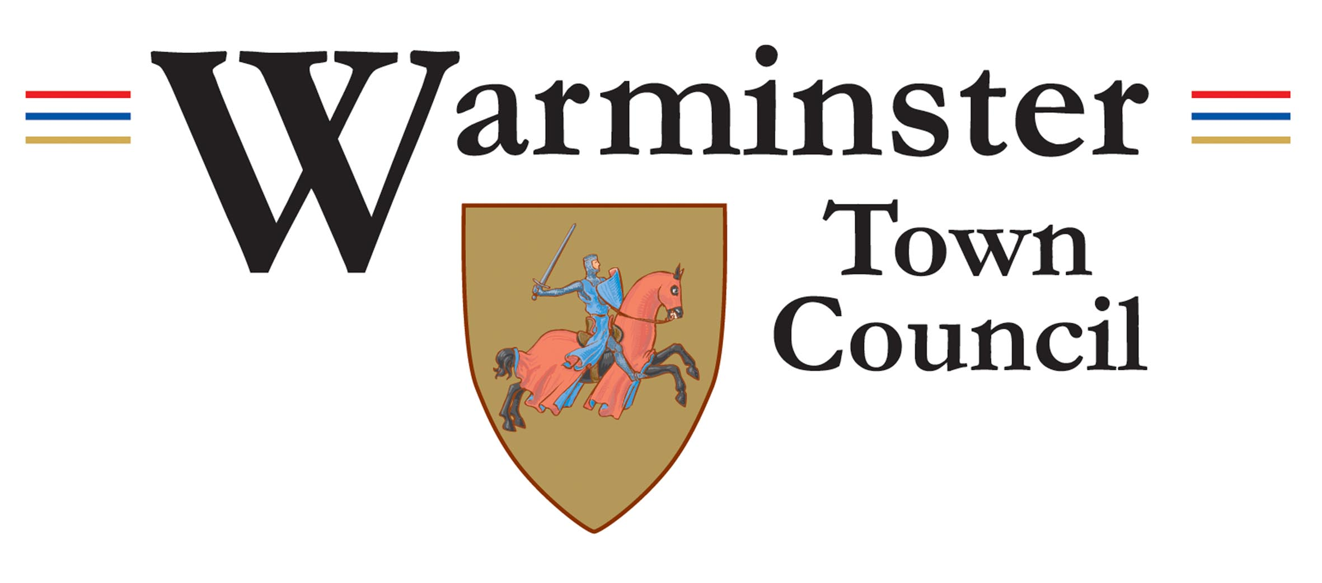 | Job Description  Facilities Maintenance Operative  June 2025

1. Core Role
The Facilities Maintenance Operative will be responsible for the general upkeep, repair, and safety of Warminster Town Council’s buildings and facilities. The postholder will carry out a range of routine maintenance tasks, ensure facilities remain operational and safe, and assist in maintaining high standards of service delivery in line with health and safety regulations.

2. Duties
(a) Carrying out routine maintenance and minor repair work on Council buildings and facilities
(b) Undertaking basic plumbing, carpentry, painting, decorating, and general DIY tasks
(c) Conducting regular inspections and reporting issues or faults to the Estates Manager
(d) Ensuring facilities are safe, secure, and in good working order
(e) Responding to maintenance requests in a timely and professional manner
(f) Assisting with the preparation and set-up of venues for Council events and activities
(g) Maintaining tools, equipment, and materials in good condition
(h) Completing relevant documentation such as maintenance logs and inspection checklists
(i) Any other reasonable duties as requested by management

3. Training
The postholder will be expected to undertake the following training, which will be provided by Warminster Town Council:
Health and Safety Awareness
Manual Handling
First Aid
Any other relevant maintenance or compliance training

4. Uniform
Staff will be expected to wear appropriate workwear. All necessary PPE and uniform items will be provided by Warminster Town Council.

Note:
The postholder may be required to perform duties other than those listed above. Responsibilities may vary from time to time without changing the general character of the post or the level of responsibility.

Hourly Rate: £15.84 – £17.79 per hour (Local Government Pay Scale SCP18–SCP24)
Hours: 21 hours per week, working 3 out of 7 days as required (including occasional weekends)

