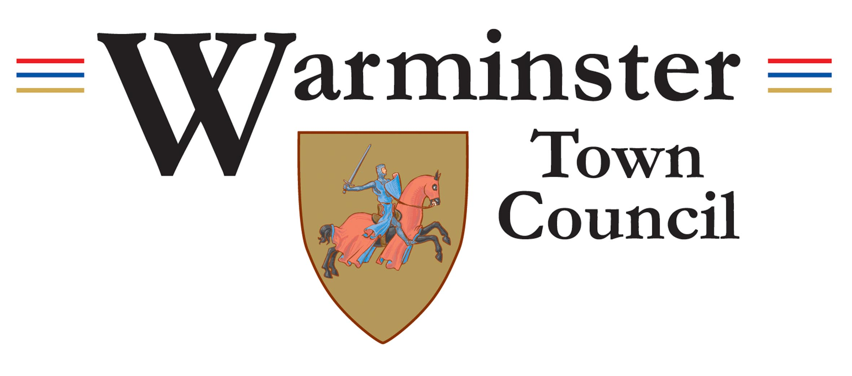 | Job Description  Seasonal Splashpad Operative  June 2025

1. Core Role
The Seasonal Splash Pad Operative will be responsible for the safe, clean, and effective day-to-day operation of the Splash Pad and surrounding areas within the Lake Pleasure Grounds during the summer season. The postholder will work as part of a small team to maintain high standards, ensure the enjoyment and safety of visitors, and provide a visible and helpful presence in one of Warminster’s most visited public spaces.

2. Duties
(a) Carrying out opening and closing procedures for the Splash Pad
(b) Monitoring the Splash Pad area to ensure it is clean, safe, and well-maintained
(c) Conducting routine checks and basic maintenance of Splash Pad equipment
(d) Reporting faults, hazards, or incidents to the appropriate supervisor
(e) Providing polite and helpful assistance to members of the public
(f) Liaising with contractors and other service providers as required
(g) Supporting the general upkeep of the Lake Pleasure Grounds, including litter picking and toilet checks
(h) Maintaining accurate records such as daily checks or incident logs when necessary
(i) Any other reasonable duties as requested by management

3. Training
The postholder will be expected to undertake the following training, which will be provided by Warminster Town Council:

Health and Safety Awareness
Manual Handling
Splash Pad Equipment Operation and Maintenance
Splash Pad Water testing

4. Uniform
Staff will be expected to wear appropriate outdoor workwear. All necessary PPE and uniform items will be provided by Warminster Town Council.

Note:
The postholder may be required to perform duties other than those listed above. Responsibilities may vary from time to time without changing the general character of the post or the level of responsibility.

Hourly Rate: £13.05 per hour (Local Government Pay Scale SCP6)
Hours: 16 hours per week, primarily at weekends
Contract: Seasonal (June – September inclusive)

